**Ethereum Dapp for Tracking Items through Supply Chain**

Project write-up – UML

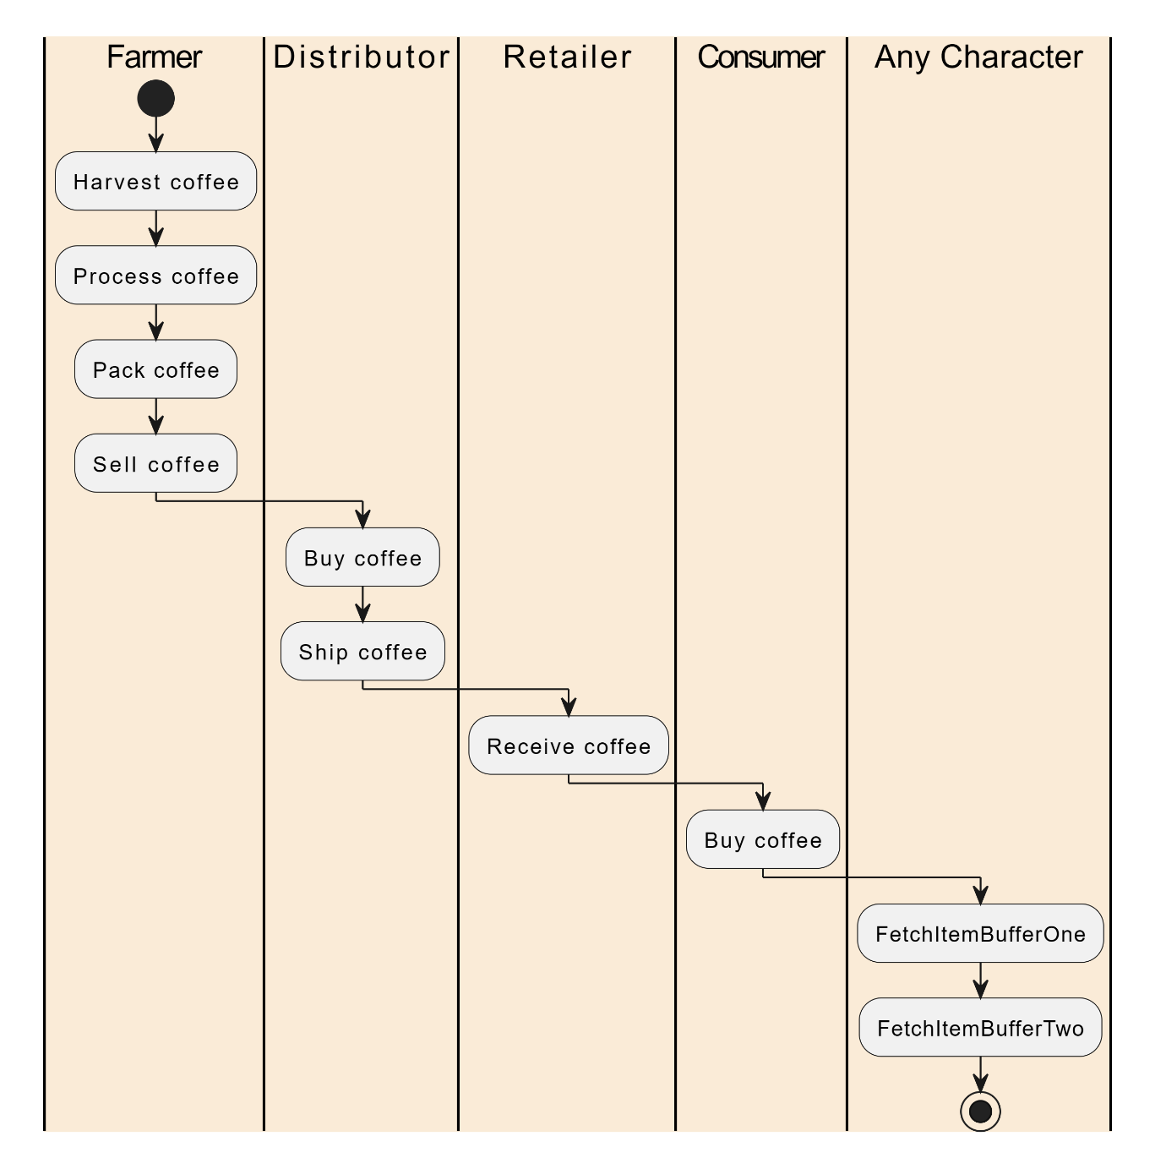Activity Diagram

Sequence Diagram

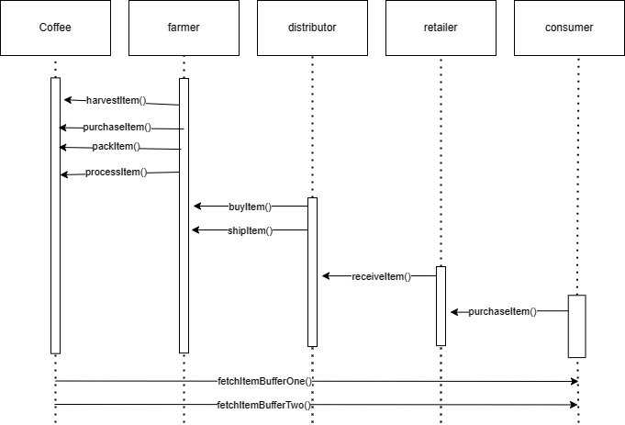

State Diagram

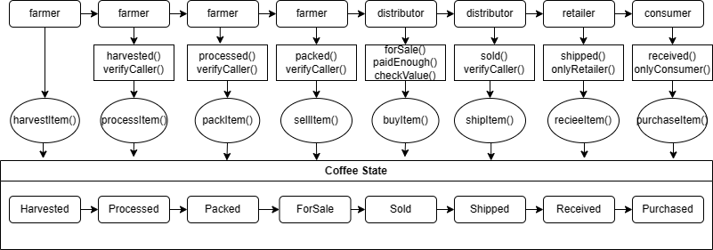

Data Modelling

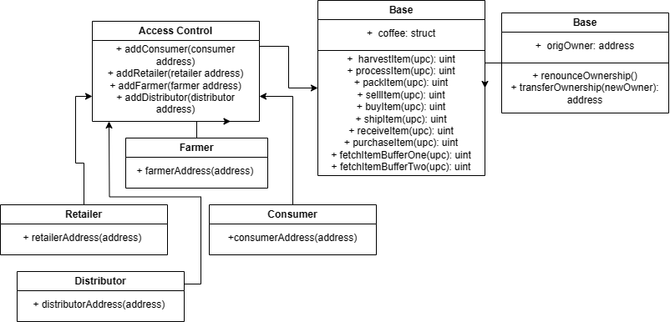

Libraries Used

* I used the hd-wallet provider library with Infura to publish the contract on the goerli test Network
* I installed web3 as well for use in of web3 implementations in app.js